CSA0976

Java Programming

Name:Y.Janardhan Reddy

Reg no: 192110083

1.

i.

import java.io.*;

import java.util.*;

class stringop1

{

public static void main(String arg[])

{

String s1,s2;

Scanner s=new Scanner(System.in);

System.out.print("Enter String 1 :");

s1=s.nextLine();

System.out.print("Enter String 2 :");

s2=s.nextLine();

int result=s1.compareToIgnoreCase(s2);

if(result==0)

{

System.out.print("Both Strings are Equal by ignoring case difference");

}

else

{

System.out.print("Both Strings are not Equal by ignoring case difference");

}

}

}

Output:

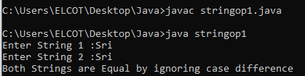

ii.

import java.io.*;

import java.util.*;

class stringop2

{

public static void main(String arg[])

{

String str1 = "The Quick Brown Fox Jumps Over The Lazy Dog";

String str2 = "The Quick Brown Fox Jumps Over The Lazy Dogs";

String end_str = "gs";

boolean ends1 = str1.endsWith(end_str);

boolean ends2 = str2.endsWith(end_str);

System.out.println("\"" + str1 + "\" ends with " +"\"" + end_str + "\"= " + ends1);

System.out.println("\"" + str2 + "\" ends with " +"\"" + end_str + "\"= " + ends2);

}

}

Output:

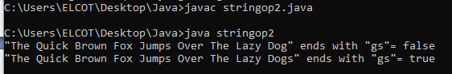

iii.

import java.io.*;

import java.util.*;

class stringop3

{

public static void main(String arg[])

{

Calendar c = Calendar.getInstance();

System.out.println("Current Date and Time :");

System.out.format("%tB %te, %tY%n", c, c, c);

System.out.format("%tl:%tM %tp%n", c, c, c);

}

}

Output:

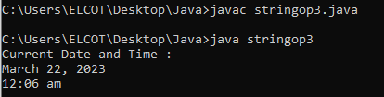

iv.

import java.io.*;

import java.util.*;

class stringop4

{

public static void main(String arg[])

{

String str = "The quick brown fox jumps over the lazy dog.";

int a = str.indexOf("a", 0);

int b = str.indexOf("b", 0);

int c = str.indexOf("c", 0);

int d = str.indexOf("d", 0);

int e = str.indexOf("e", 0);

int f = str.indexOf("f", 0);

int g = str.indexOf("g", 0);

int h = str.indexOf("h", 0);

int i = str.indexOf("i", 0);

int j = str.indexOf("j", 0);

int k = str.indexOf("k", 0);

int l = str.indexOf("l", 0);

int m = str.indexOf("m", 0);

int n = str.indexOf("n", 0);

int o = str.indexOf("o", 0);

int p = str.indexOf("p", 0);

int q = str.indexOf("q", 0);

int r = str.indexOf("r", 0);

int s = str.indexOf("s", 0);

int t = str.indexOf("t", 0);

int u = str.indexOf("u", 0);

int v = str.indexOf("v", 0);

int w = str.indexOf("w", 0);

int x = str.indexOf("x", 0);

int y = str.indexOf("y", 0);

int z = str.indexOf("z", 0);

System.out.println(" a b c d e f g h i j");

System.out.println("=========================");

System.out.println(a + " " + b + " " + c + " " + d + " " +

e + " " + f + " " + g + " " + h + " " +

i + " " + j + "\n");

System.out.println("k l m n o p q r s t");

System.out.println("===========================");

System.out.println(k + " " + l + " " + m + " " + n + " " +

o + " " + p + " " + q + " " + r + " " +

s + " " + t + "\n");

System.out.println("u v w x y z");

System.out.println("================");

System.out.println(u + " " + v + " " + w + " " + x + " " +

y + " " + z);

}

}

Output:

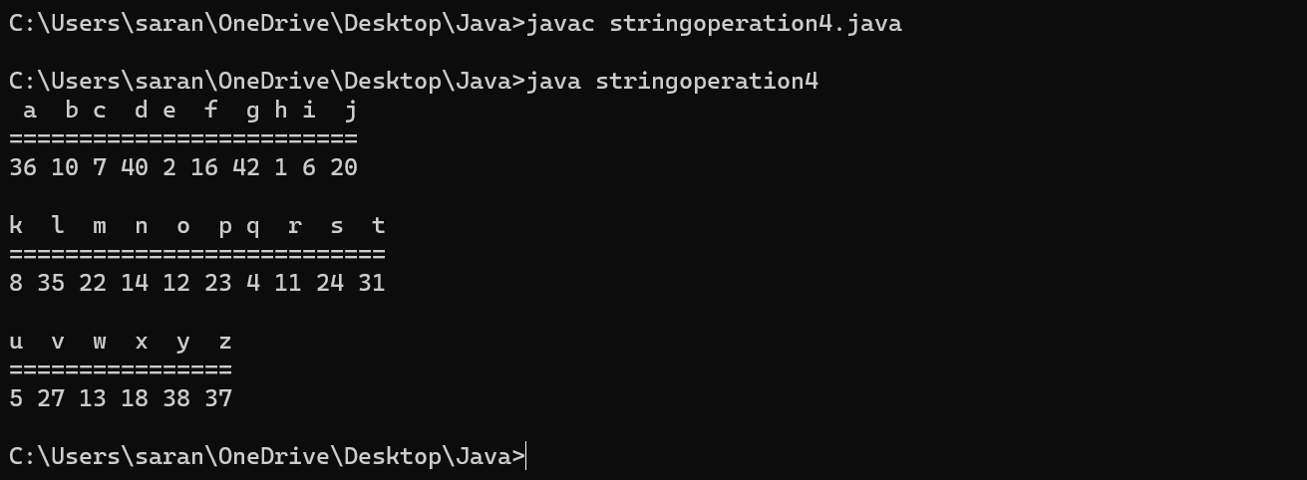

v.

import java.io.*;

import java.util.*;

class stringop5

{

public static void main(String arg[])

{

String str = "The quick brown fox jumps over the lazy dog.";

String new_str = str.replaceAll("fox", "cat");

System.out.println("Original string: " + str);

System.out.println("New String: " + new_str);

}

}

Output:

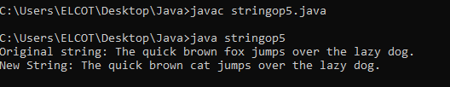

vi.

import java.io.*;

import java.util.*;

class stringop6

{

public static void main(String arg[])

{

String str = "The quick brown fox jumps over the lazy dog."; String new_str = str.substring(10, 26);

System.out.println("old = " + str);

System.out.println("new = " + new_str);

}

}

Output:

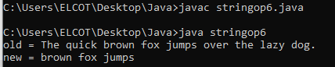

vii.

import java.io.*;

import java.util.*;

class stringop7

{

public static void main(String arg[])

{

String str = " The quick brown fox jumps over the lazy dog. ";

String new_str = str.trim();

System.out.println("Original String: " + str);

System.out.println("New String: " + new_str);

}

}

Output:

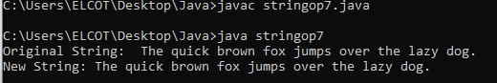

viii.

import java.io.*;

import java.util.*;

class stringop8

{

public static void main(String arg[])

{

String str = “The quick brown fox jumps over the lazy dog”;

String lowerStr = str.toLowerCase();

System.out.println("Original String: " + str);

System.out.println("String in lowercase: " + lowerStr);

}

}

Output:

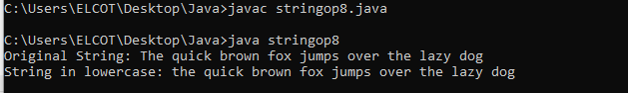

ix.

import java.io.*;

import java.util.*;

class stringop9

{

public static void main(String arg[])

{

String str = "The quick brown fox jumps over the lazy dog";

int len = str.length();

System.out.println("The string length of '"+str+"' is: "+len);

}

}

Output:

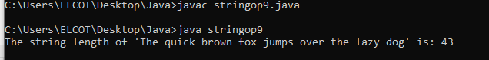x.

import java.io.*;

import java.util.*;

class stringop10

{

public static void main(String arg[])

{

String columnist1 = "The quick brown fox jumps over the lazy dog";

String columnist2 = "The quick brown fox jumps over the lazy dog";

boolean equals1 = columnist1.equals(columnist2);

System.out.println("\"" + columnist1 + "\" equals \"" +columnist2 + "\"=" + equals1);

}

}

Output:



2.

import java.io.*;

import java.util.*;

class account

{

static double balance=0;

public static void main(String arg[])

{

Scanner s=new Scanner(System.in);

while(true)

{

System.out.print("Press 1 to continue...");

int y=s.nextInt();

if(y==1)

{

choice();

}

else

{

break;

}

}

}

public static void Account()

{

System.out.println(balance);

}

public static void deposit(double amount)

{

balance += amount;

System.out.println("Amount is deposited");

}

public static void withdraw(double amount)

{

if (balance >= amount)

{

balance -= amount;

System.out.println(amount+" is withdrawed");

}

else

{

System.out.println("Insufficient funds");

}

}

public static void choice()

{

System.out.println("1.Check Balance");

System.out.println("2.Deposit");

System.out.println("3.Withdraw");

System.out.print("Enter your choice");

Scanner s1=new Scanner(System.in);

int i=s1.nextInt();

if(i==1)

{

Account();

}

else if(i==2)

{

System.out.print("Enter amount to be deposit :");

int amount=s1.nextInt();

deposit(amount);

}

else if(i==3)

{

System.out.print("Enter amount to be withdraw :");

int amount=s1.nextInt();

withdraw(amount);

}

else

{

System.out.print("Invalid Choice ");

}

}

}

Output:

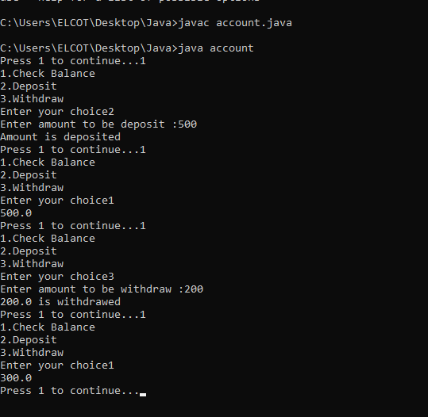

3.

import java.io.*;

import java.util.*;

class needlehaystack

{

public static void main(String[] args)

{

String needle;

String haystack;

Scanner c=new Scanner(System.in);

System.out.print("Haystack :");

haystack=c.nextLine();

System.out.print("needle :");

needle=c.nextLine();

int index = haystack.indexOf(needle);

if (index == -1)

{

System.out.println(needle+" not found in "+haystack);

}

else

{

System.out.println(needle+" found at index " + index);

}

}

}

Output:

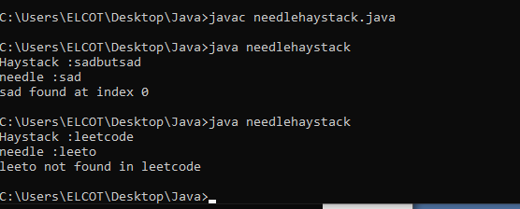

4.

import java.io.*;

import java.util.*;

class lastword

{

public static void main(String arg[])

{

String s;

Scanner c=new Scanner(System.in);

System.out.print("Enter a String :");

s=c.nextLine();

System.out.print("Length of last word :"+lengthOfLastWord(s));

}

public static int lengthOfLastWord(String s)

{

int count = 0;

s = s.trim();

int start = s.length() - 1;

for(int i=start; i>= 0; i--)

{

if(s.charAt(i)==' ')

{

break;

}

count++;

}

return count;

}

}

Output:

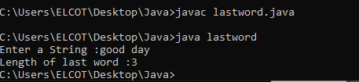

5.

import java.io.*;

import java.util.*;

class Factor

{

public static void main(String args[])

{

try

{

Scanner sc=new Scanner(System.in);

int count=0,n,i,j=0,m=4;

int []a=new int [10];

System.out.print("Enter the number:");

n=sc.nextInt();

if(n<=0)

{

System.out.println("Enter valid number");

}

else

{

for(i=1;i<=n;i++)

{

if(n%i==0)

{

a[j] = i;

System.out.println("..." + i);

count++;

j++;

}

}

System.out.println("The number of factors:"+count);

}

System.out.println(m + "th item " + a[m-1]);

}

catch(Exception e)

{

System.out.println("Enter only numbers");

}

}

}

Output:

